**DDL and DML Query Output**

**SQL Query Output**

* **Query 1: Select all columns and all rows from one table (5 points)**

* **Query 2: Select five columns and all rows from one table (5 points)**

* **Query 3: Select all columns from all rows from one view (5 points)**

* **Query 4: Using a join on 2 tables, select all columns and all rows from the tables without the use of a Cartesian product (5 points)**

* **Query 5: Select and order data retrieved from one table (5 points)**

* **Query 6: Using a join on 3 tables, select 5 columns from the 3 tables. Use syntax that would limit the output to 3 rows (5 points)**

* **Query 7: Select distinct rows using joins on 3 tables (5 points)**

* **Query 8: Use GROUP BY and HAVING in a select statement using one or more tables (5 points)**

* **Query 9: Use IN clause to select data from one or more tables (5 points)**

* **Query 10: Select length of one column from one table (use LENGTH function) (5 points)**

* **Query 11: Delete one record from one table. Use select statements to demonstrate the table contents before and after the DELETE statement. Make sure you use ROLLBACK afterwards so that the data will not be physically removed (5 points)**

* **Query 12: Update one record from one table. Use select statements to demonstrate the table contents before and after the UPDATE statement. Make sure you use ROLLBACK afterwards so that the data will not be physically removed (5 points)**

* **Query 13 (Advanced Query) – Find out the appointment details of all doctors who have more than 2 appointments**

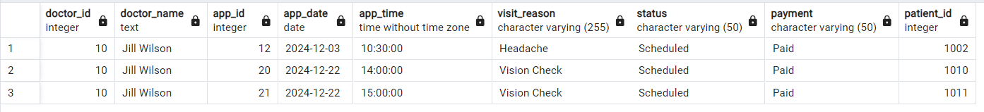

* **Query 14 (Advanced Query) – Find out which payment method generates the most revenue for the hospital.**

